**BS. INFORMATION TECHNOLOGY**

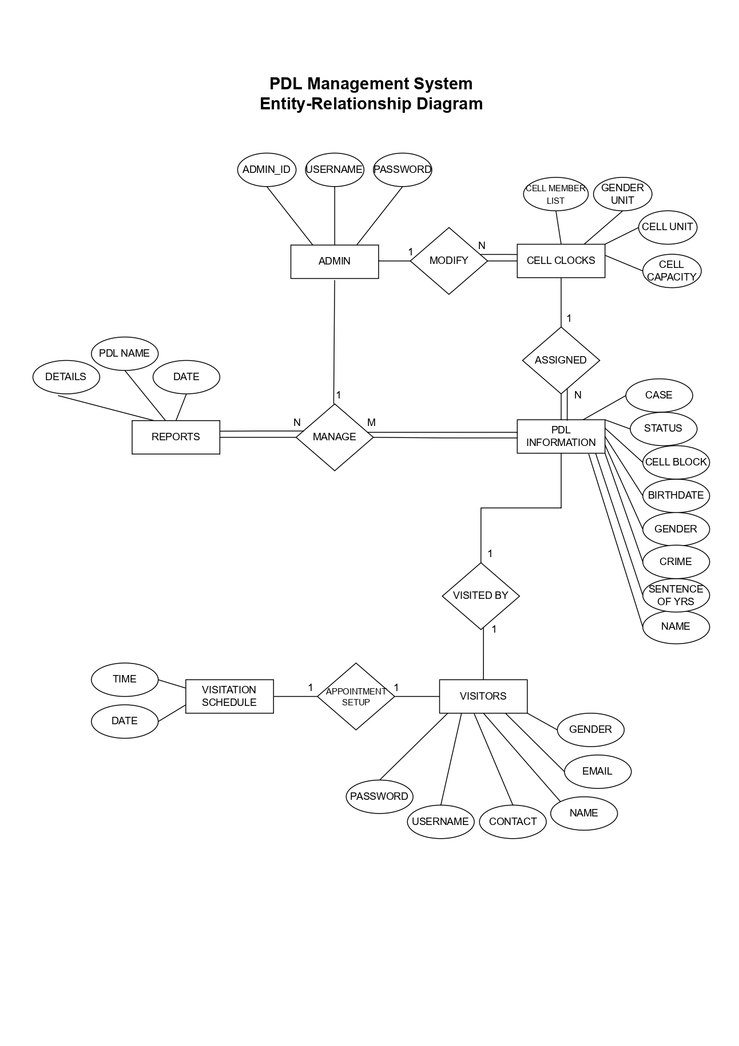**PDL MANAGEMENT SYSTEM – ENTITY RELATIONSHIP DIAGRAM**

Prepared by:

**Leader: JUSTINE NORIE B. DELA CRUZ**

**Group 2 – PDL Management System**

Checked by:

**RIZZA MAE BRAO**